 | SR UNIVERSITY  Campus Warangal
 | Program: II - B. Tech (CS& AI) Batch:
 | Faculty’s: Dr. Mathivanan
 | Department: Computer Science and AI Semester: 3
 | AI Assisted Coding-Assignment 07 Date: 19/9/2026
Name -Himanshu Kumar
Roll no-2503A54045
Batch-58

Q1. Class with Conditional Logic – Employee Salary
Scenario:
An AI coding assistant is used to develop a simple employee salary management program.
Task:
Using AI-assisted code completion, write a Python class Employee that:
- Stores employee name and basic salary.
- Has a method calculate_bonus() that:
  - Returns 10% of salary if salary is ₹50,000 or above.
  - Returns 5% of salary otherwise.
- Has a method display_details() to display the employee name, salary, and bonus.
- Create at least two employee objects and test the class.
Prompt:
Generate a complete, executable Python program for an Employee Salary Calculator using Object-Oriented Programming. Requirements: Create a class named Employee with attributes name and basic_salary. Add a method calculate_bonus() that returns a 10% bonus if basic_salary >= 50000, otherwise 5%. Add a method calculate_total_salary() returning basic_salary + bonus. Include a display_details() method showing Name, Basic Salary, Bonus, and Total Salary. Instantiate objects testing salaries below, equal to, and above ₹50,000. Use brief inline comments and clean standard formatting.
Python Code
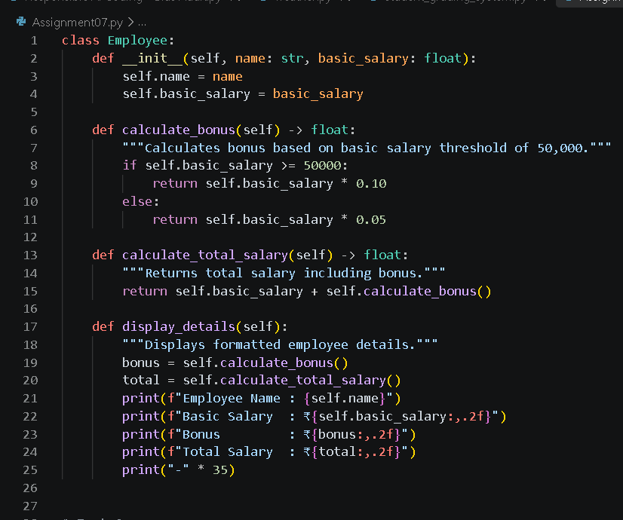
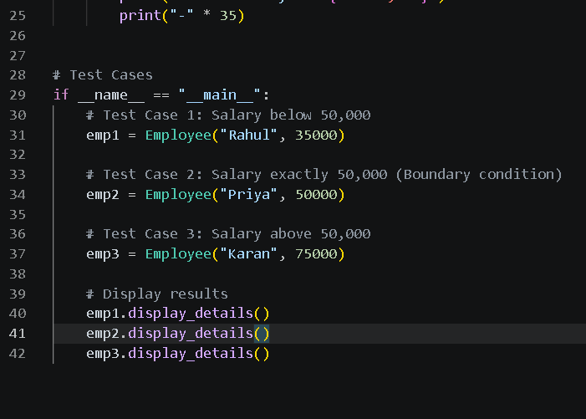
Output:
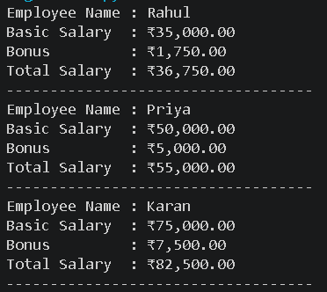
Observation:
• Key Finding: The threshold condition (salary >= 50000) correctly applies a 10% bonus for salaries $≥₹50,000$ and 5% for lower values.
• Boundary Check: Exactly ₹50,000 correctly triggers the 10% tier

Q2. Loop and Conditional Logic – Student Marks
Scenario:
A teacher wants to analyze the marks of students using an AI coding assistant.
Task:
Using AI-assisted code completion, write a Python program that:
- Accepts a list of student marks.
- Uses a loop to process each mark.
- Displays:
  - "Distinction" for marks ≥ 75
  - "Pass" for marks ≥ 40 and < 75
  - "Fail" for marks < 40
- Ignores invalid marks outside 0–100.
- Calculates and displays the number of students in each category.
- Test the program with a suitable list of marks.
Prompt:
Write a Python script to process a list of student marks using loops and conditional logic. Categorize marks as follows: "Distinction" (>= 75), "Pass" (40 to 74), and "Fail" (< 40). Ignore invalid marks outside the 0–100 range. Keep track of and display the total counts for each category. Include a test list containing valid and invalid marks.
Code:
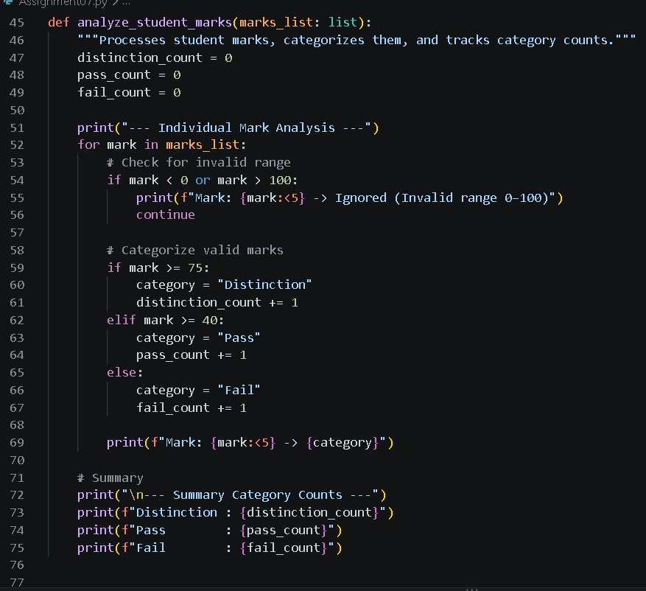
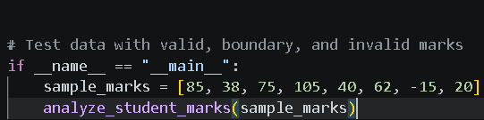
Output:
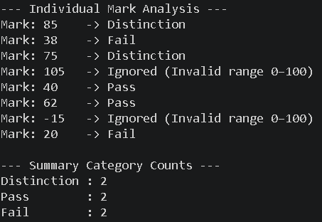
Observation:
• Key Finding: Input validation skips out-of-range values ($<0$ or $>100$) using continue.
• Classification: Valid marks are correctly categorized into Distinction ($≥75$), Pass ($40-74$), and Fail ($<40$) with accurate category counts.

Q3. Class + Loop – Product Inventory
Scenario:
A small store wants to maintain product inventory using a Python program generated with AI assistance.
Task:
Using AI-assisted code completion, create a class Product that:
- Stores product name, price, and quantity.
- Has a method total_value() that calculates price × quantity.
- Create a list of multiple Product objects.
- Use a loop to calculate the total inventory value.
- Display the products whose quantity is less than 5 as "Low Stock".
- Test the program with at least three products.
Prompt:
Create a Python program with a Product class having name, price, and quantity attributes, along with a total_value() method. Create a list of multiple Product objects, iterate through them using a loop to compute the grand inventory value, and flag any item with quantity less than 5 as "Low Stock".
Code:
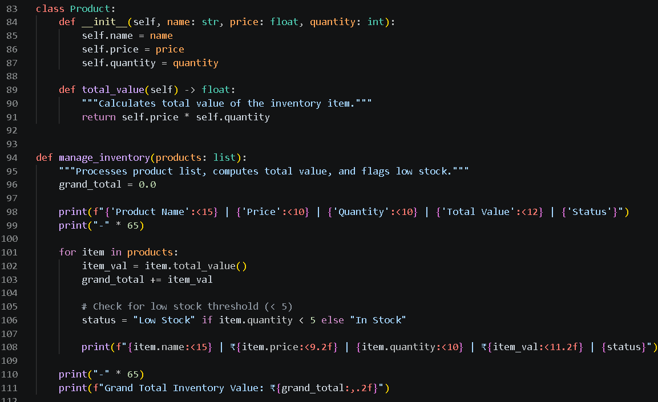
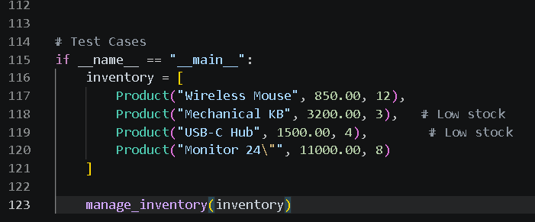
Output:
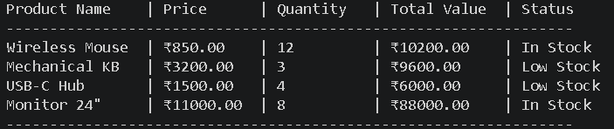
Observation:
• Key Finding: Iterating over object lists correctly accumulates the grand inventory total ($\sum{\text{price}}×\text{quantity}$).
• Stock Alert: Items with $\text{quantity}<5$ are accurately flagged as "Low Stock".

Q4. Class + Loop + Nested Conditions – Electricity Bill
Scenario:
An electricity board wants to calculate bills based on units consumed.
Task:
Using AI-assisted code completion, create a Python class ElectricityBill that:
- Stores the consumer name and units consumed.
- Calculates the bill using:
  - First 100 units → ₹2/unit
  - 101–200 units → ₹3/unit
  - Above 200 units → ₹5/unit
- Uses appropriate loops and conditional statements where required.
- Displays the consumer name, units, and total bill.
- Create at least three objects and display their bills.
- Test the program with different unit values, including an edge value such as 100 or 200.
Prompt:
Write a Python program using an ElectricityBill class with attributes consumer_name and units. Implement slab-based billing logic: first 100 units at ₹2/unit, 101–200 units at ₹3/unit, and above 200 units at ₹5/unit. Instantiate at least 3 objects including boundary/edge test cases (e.g., 100 and 200 units) and display the bill details.
Code:
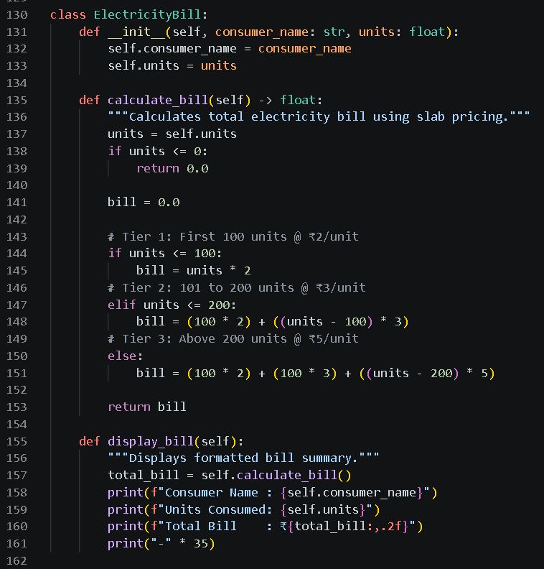
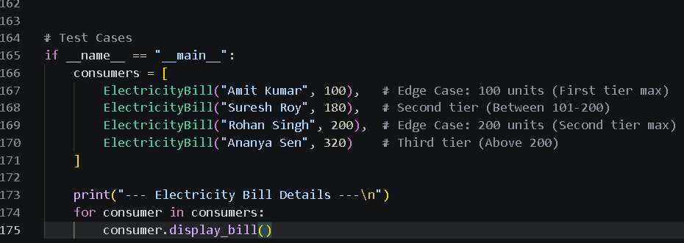
Output:
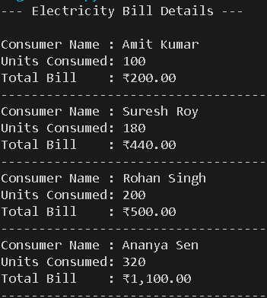
Observation:
• Key Finding: Incremental slab calculations work accurately—charging ₹2/unit (1–100), ₹3/unit (101–200), and ₹5/unit ($>200$).
• Boundary Check: Edge inputs at 100 and 200 units transition smoothly between price slabs without overcharging earlier tiers.

